Constraint-Based Problem Solving
Exam Timetable Scheduling as a Constraint Satisfaction Problem

1. Scenario
A university must schedule the final examinations of five courses into three exam slots (one exam per day over three days). Two courses that share students cannot be placed in the same slot. The courses are: A – Artificial Intelligence, B – Database Systems, C – Computer Networks, D – Operating Systems, E – Software Engineering.

2. Conflicting pairs (must receive different slots)
No. | Pair | Meaning
1 | A – B | AI and DBMS share students
2 | A – C | AI and Networks share students
3 | B – C | DBMS and Networks share students
4 | B – D | DBMS and OS share students
5 | C – D | Networks and OS share students
6 | C – E | Networks and Software Engineering share students
7 | D – E | OS and Software Engineering share students

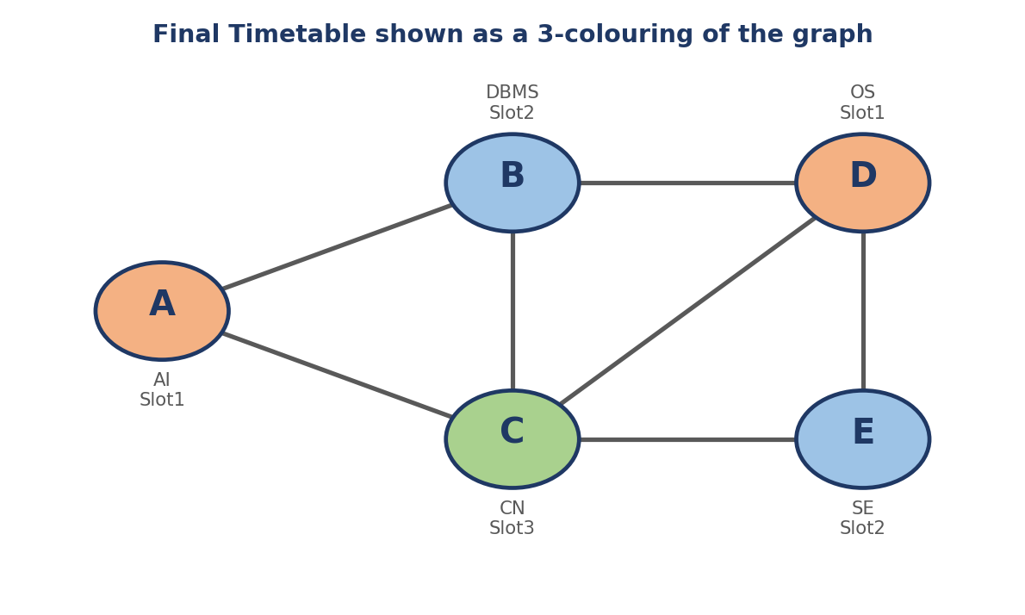

Figure 1: Final timetable displayed as a colouring of the constraint graph (same colour = same slot).

Part (a) – PEAS Description
a.1 PEAS Need
PEAS (Performance measure, Environment, Actuators, Sensors) is the standard framework for specifying the task environment of an intelligent agent before its design is attempted. Defining PEAS first makes it clear what “success” means, what the agent can sense, and what it is able to change. Here the agent is an automated exam-scheduling agent whose job is to build a conflict-free timetable.

a.2 PEAS table
PEAS element | Description for the exam-scheduling agent | Justification
Performance measure | • Number of violated constraints = 0 (hard requirement)  • All 5 courses assigned to exactly one slot  • Only the 3 available slots used  • Computation cost (assignment attempts / backtracks) kept low  • Optional: balanced load across slots | A timetable is only useful if no student has two exams in the same slot, so conflict-freeness is the primary measure. Search effort measures the efficiency of the agent.
Environment | • 5 courses (A–E) and 3 exam slots (Slot1–Slot3)  • Student-enrolment data defining the 7 conflicting pairs  • The current (partial) timetable  • University exam rules (one exam per course per slot) | These are all the external objects and rules the agent must reason about; they do not change while the agent plans.
Actuators | • Assign a slot to a course  • Un-assign / change a slot (backtracking)  • Prune values from domains (internal reasoning action)  • Publish / display the final timetable to students and staff | Actuators are what the agent can do to change the state of the timetable and communicate the result.
Sensors | • Reads the course list and slot list  • Reads the conflict list from the registration database  • Observes the current partial assignment  • Detects constraint violations or empty domains | The agent needs the conflict data and its own current state to decide which assignment is legal.

a.3 Task-environment properties

Property | Value | Justification
Observability | Fully observable | All courses, slots and conflicts are known to the agent at the start.
Agents | Single agent | Only the scheduler acts; no competing agents.
Determinism | Deterministic | Assigning a slot always has the same effect on the timetable.
Episodic / Sequential | Sequential | Each assignment constrains later assignments (e.g. A=Slot1 forbids Slot1 for B and C).
Static / Dynamic | Static | Enrolment data does not change while the timetable is being computed.
Discrete / Continuous | Discrete | Finite variables (5) and finite values (3 slots).
Known / Unknown | Known | The rules (constraints) are given completely.

a.4 Justification of the PEAS design
- Performance measure is stated as hard constraints (zero conflicts) because a single clash makes the timetable invalid; efficiency is a secondary measure that is used later in Part (f).
- Environment is limited to what affects the decision, which keeps the model small and lets it be written as a CSP in Part (c).
- Actuators include un-assigning because backtracking search must be able to undo earlier decisions.
- Sensors include detection of empty domains because forward checking (Part e) uses this signal to detect dead ends early.

Part (b) – Agent Type Classification

b.1 Candidate agent types compared

Agent type | How it decides | Suitable here? | Reason
Simple reflex | Condition–action rules on the current percept only | No | A conflict-free timetable depends on all earlier assignments, not just the current percept. Fixed rules cannot handle every combination.
Model-based reflex | Keeps internal state/model, still uses rules | Partly | Tracking the partial timetable is needed, but there is no explicit goal or look-ahead, so it cannot plan around dead ends.
Goal-based | Uses a model + explicit goal + search/planning | Yes – best | The task has a clear goal (all constraints satisfied) and requires searching through assignments.
Utility-based | Maximises a utility function over outcomes | Not required | Every valid timetable is equally acceptable; there is no numeric preference between solutions.

b.2 Selected agent type: Goal-based agent
The exam scheduler is best classified as a goal-based agent that maintains an internal model of the partially built timetable and searches (backtracking / forward checking) until the goal test “all 7 constraints satisfied and all courses assigned” is true.

b.3 Justification points
- Explicit goal. The goal state is well defined: every course has a slot and no conflicting pair shares a slot. A goal-based agent is built around exactly this kind of goal test.
- Need for look-ahead / search. Choosing Slot1 for A affects B, C and, indirectly, D and E. The agent must consider the consequences of an action before committing, which is what search provides.
- Internal model. The agent stores the current partial assignment and the conflict graph, so it knows what is legal. This is the “model” part used by goal-based agents.
- Flexibility. If a constraint changes (e.g. a new conflict D–A), the goal and model are updated and the same search runs again. A reflex agent would need all of its rules rewritten.
- A utility-based agent would be required only if there were quality preferences (e.g. minimise the number of students having exams on consecutive days). The question only asks for a conflict-free timetable, which is a yes/no goal.

b.4 Agent program (pseudo-code)
function EXAM-SCHEDULING-AGENT(percept) returns an action
persistent: model <- (courses, slots, conflict graph)
state <- current partial timetable
goal <- "all courses assigned, no conflicting pair in same slot"
state <- UPDATE-STATE(state, percept, model)
if GOAL-TEST(state) then return PUBLISH(state)
plan <- CSP-SEARCH(state, model) # backtracking / forward checking
if plan = failure then return REPORT("no feasible timetable")
return FIRST-ACTION(plan) # e.g. ASSIGN(A, Slot1)

Part (c) – CSP Formulation and Constraint Graph

c.1 Definition of a CSP
A Constraint Satisfaction Problem is defined by a triple (X, D, C): a set of variables X, a domain D of allowed values for each variable, and a set of constraints C that restrict which combinations of values are allowed. A solution is a complete and consistent assignment, i.e. every variable has a value and no constraint is violated.

c.2 Variables (X)

Variable | Course | Meaning
A | Artificial Intelligence | Exam slot assigned to AI
B | Database Systems | Exam slot assigned to DBMS
C | Computer Networks | Exam slot assigned to CN
D | Operating Systems | Exam slot assigned to OS
E | Software Engineering | Exam slot assigned to SE

X = {A, B, C, D, E}. Justification: each course needs exactly one slot, so one variable per course is the natural choice.

c.3 Domains (D)

Variable | Domain
A | {Slot1, Slot2, Slot3}
B | {Slot1, Slot2, Slot3}
C | {Slot1, Slot2, Slot3}
D | {Slot1, Slot2, Slot3}
E | {Slot1, Slot2, Slot3}
Justification: the university has exactly three exam slots, and no course is restricted to particular slots, so all domains are identical with size 3. The unconstrained search space contains 3^5 = 243 complete assignments.

c.4 Constraints (C)
Every conflicting pair gives one binary inequality constraint (the two courses must differ in slot):

ID | Constraint | Allowed value pairs | Reason
C1 | A ≠ B | 6 of 9 pairs | Shared students in AI and DBMS
C2 | A ≠ C | 6 of 9 pairs | Shared students in AI and CN
C3 | B ≠ C | 6 of 9 pairs | Shared students in DBMS and CN
C4 | B ≠ D | 6 of 9 pairs | Shared students in DBMS and OS
C5 | C ≠ D | 6 of 9 pairs | Shared students in CN and OS
C6 | C ≠ E | 6 of 9 pairs | Shared students in CN and SE
C7 | D ≠ E | 6 of 9 pairs | Shared students in OS and SE
Pairs that are not listed (A–D, A–E, B–E) have no constraint, so these courses may share a slot. All constraints are binary, so the problem is a binary CSP and can be drawn as a graph.

c.5 Constraint graph
In a constraint graph each variable is a vertex and each binary constraint is an edge joining the two variables.
Item | Content
Vertices (5) | A, B, C, D, E
Edges (7) | (A,B), (A,C), (B,C), (B,D), (C,D), (C,E), (D,E)

Vertex | Neighbours (adjacency list) | Degree
A | B, C | 2
B | A, C, D | 3
C | A, B, D, E | 4
D | B, C, E | 3
E | C, D | 2
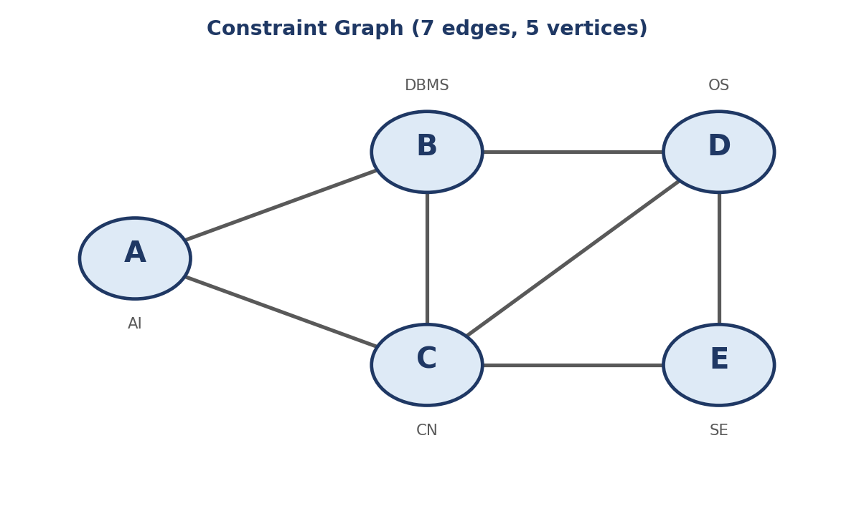
Figure 2: Constraint graph of the exam-scheduling CSP.

c.6 Structural observations (justification and insight)
- Total degree = 14 = 2 × 7 edges, which confirms that the adjacency list matches the edge list.
- C has the highest degree (4), so it is the most constrained variable. Choosing it early (an MRV/degree heuristic) would reduce search in general, but the question requires the fixed order A → B → C → D → E.
- The graph is a chain of three triangles: {A,B,C}, {B,C,D} and {C,D,E}. Because each triangle needs 3 different slots, at least 3 slots are needed, and we have exactly 3, so the CSP is solvable only if the 3-colouring is tight.
- Once A, B, C take three different slots, D must equal A’s slot (D differs from B and C) and E must equal B’s slot (E differs from C and D). Hence there are exactly 3! = 6 valid timetables, one for each ordering of the three slots over A, B, C. The search in Parts (d) and (e) finds the first of these.

c.7 Python representation of the CSP
VARIABLES = ["A", "B", "C", "D", "E"]
DOMAIN = ["Slot1", "Slot2", "Slot3"]
EDGES = [("A","B"),("A","C"),("B","C"),("B","D"),
("C","D"),("C","E"),("D","E")] # constraints: u != v
NEIGHBOURS = {v: set() for v in VARIABLES}
for u, v in EDGES:
NEIGHBOURS[u].add(v); NEIGHBOURS[v].add(u)

Part (d) – Plain Backtracking Search

d.1 Method and assumptions
- Backtracking search is a depth-first search that assigns one variable at a time and checks each new assignment only against variables that are already assigned. If no value works for a variable, the algorithm undoes the previous assignment (backtracks) and tries its next value.
- Variable order (static): A → B → C → D → E. Value order: Slot1 → Slot2 → Slot3 (written S1, S2, S3 in the tables).
- Counting rules used: an assignment attempt is every time a value is tried for a variable; a rejected attempt is an attempt that violates a constraint; a backtrack is the undoing of an earlier accepted assignment because a later variable has no legal value left.

d.2 Algorithm
function BACKTRACKING-SEARCH(csp) return RECURSIVE-BT({}, csp)

function RECURSIVE-BT(assignment, csp)
if assignment is complete then return assignment
var <- next unassigned variable in order A,B,C,D,E
for each value in [Slot1, Slot2, Slot3] do
if value is consistent with assignment (no assigned neighbour has it) then
add {var = value} to assignment
result <- RECURSIVE-BT(assignment, csp)
if result != failure then return result
remove {var = value} from assignment # BACKTRACK
return failure

d.3 Flowchart of plain backtracking
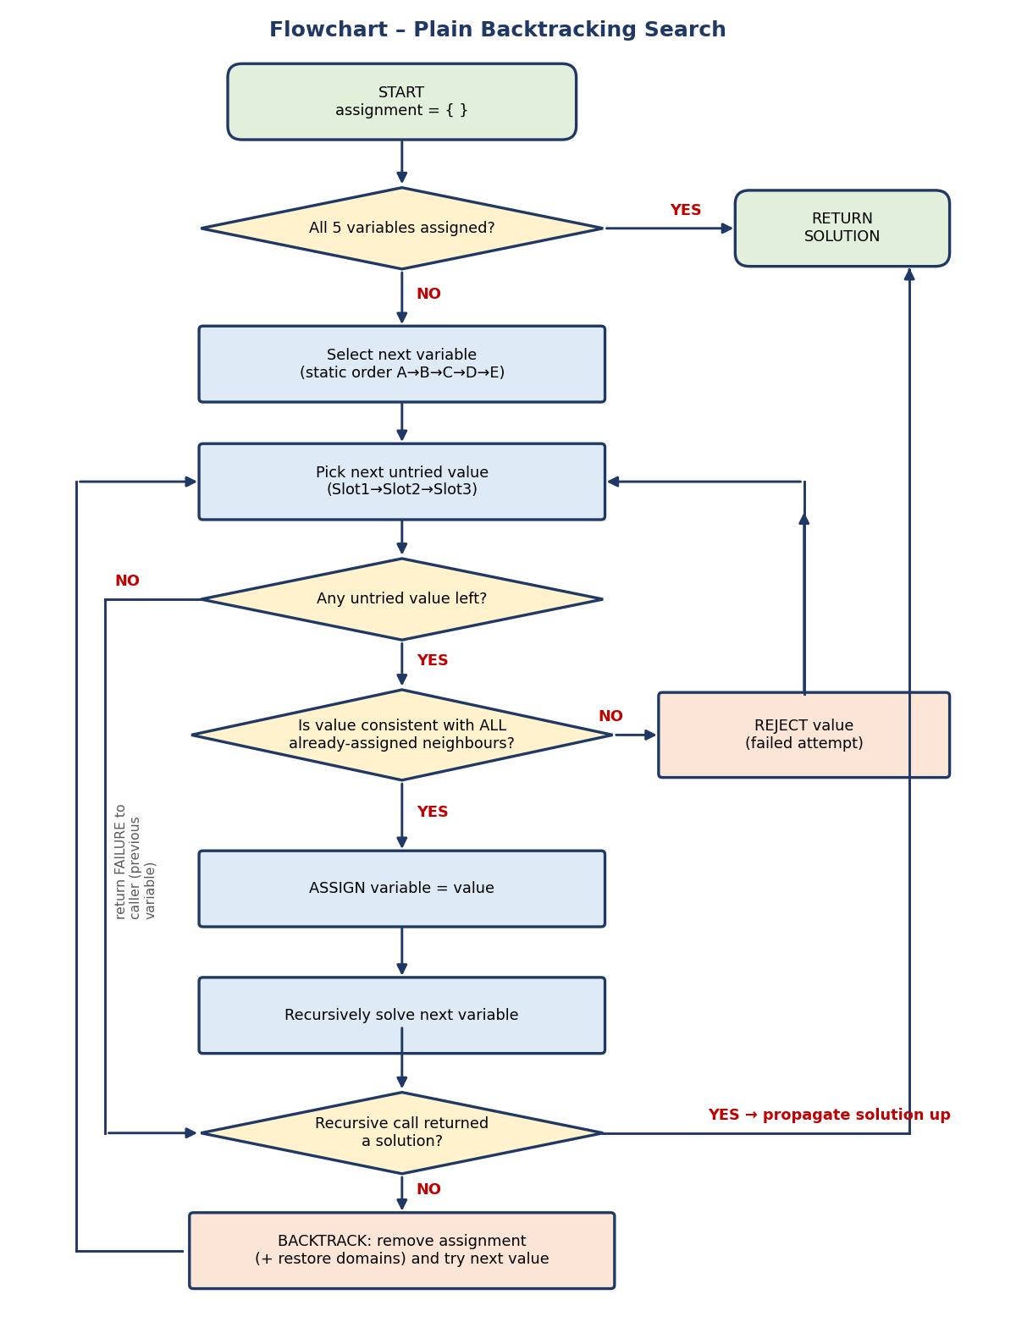
Figure 3: Flowchart of plain backtracking search.

d.4 Step-by-step table of every assignment attempt
Step | Var | Value tried | Consistency check against assigned neighbours | Result | Partial assignment after step
1 | A | Slot1 | No assigned neighbours | Accepted | {A=S1}
2 | B | Slot1 | A=S1 → same slot (A≠B violated) | Rejected | {A=S1}
3 | B | Slot2 | A=S1 ≠ S2 ✔ | Accepted | {A=S1, B=S2}
4 | C | Slot1 | A=S1 → same slot (A≠C violated) | Rejected | {A=S1, B=S2}
5 | C | Slot2 | B=S2 → same slot (B≠C violated) | Rejected | {A=S1, B=S2}
6 | C | Slot3 | A=S1 ✔, B=S2 ✔ | Accepted | {A=S1, B=S2, C=S3}
7 | D | Slot1 | B=S2 ✔, C=S3 ✔ (E not yet assigned) | Accepted | {A=S1, B=S2, C=S3, D=S1}
8 | E | Slot1 | C=S3 ✔, D=S1 → same slot (D≠E violated) | Rejected | {A=S1, B=S2, C=S3, D=S1}
9 | E | Slot2 | C=S3 ✔, D=S1 ✔ | Accepted | {A=S1, B=S2, C=S3, D=S1, E=S2} → COMPLETE

d.5 Explanation of the key steps
- Step 2 (B=S1 rejected). B is adjacent to A and A already holds Slot1, so Slot1 is illegal. The algorithm simply tries the next value, Slot2 (Step 3).
- Steps 4–5 (C=S1 and C=S2 rejected). C is adjacent to both A (S1) and B (S2), so only Slot3 survives. Two attempts were wasted before reaching it. This is the biggest saving available to forward checking in Part (e).
- Step 7 (D=S1 accepted). D is adjacent to B (S2) and C (S3) but not to A, so Slot1 is allowed even though A uses it.
- Step 8 (E=S1 rejected). E is adjacent to D (S1), so Slot1 is illegal; Slot2 is legal because C=S3 and D=S1 (Step 9).
- Backtracking steps. Every variable found a legal value before its domain was exhausted, so no earlier assignment ever had to be undone: 0 backtracks. The four rejected attempts are local retries within one variable.

d.6 Search tree
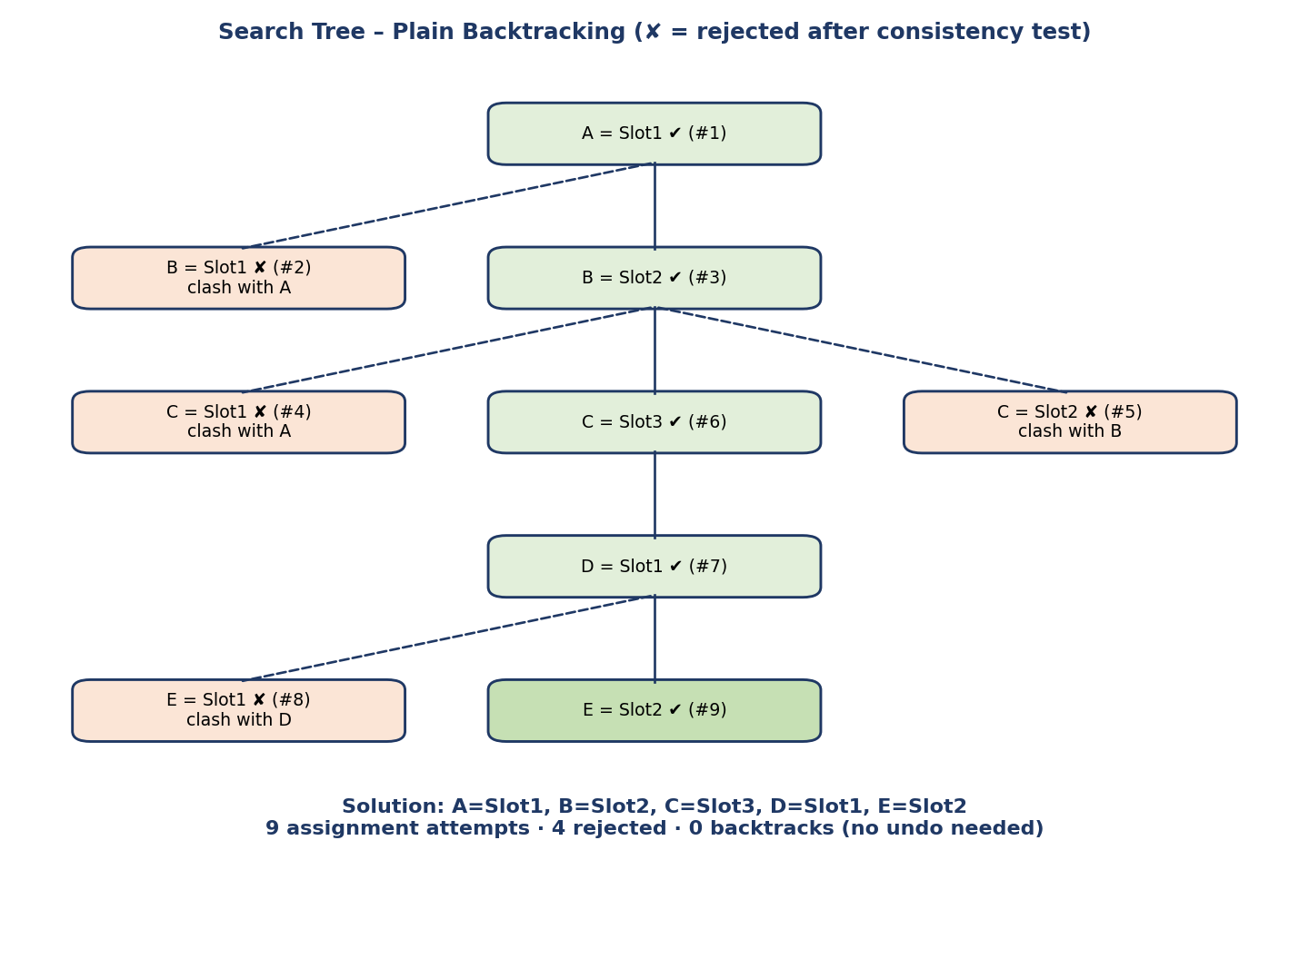
Figure 4: Search tree for plain backtracking. Numbers in brackets are the step numbers from the table.

d.7 Final valid timetable

Exam slot | Course(s) scheduled | Day
Slot1 | A – Artificial Intelligence, D – Operating Systems | Day 1
Slot2 | B – Database Systems, E – Software Engineering | Day 2
Slot3 | C – Computer Networks | Day 3

Assignment: A = Slot1, B = Slot2, C = Slot3, D = Slot1, E = Slot2.

d.8 Verification of the solution against every constraint
Constraint | Values | Satisfied?
A ≠ B | Slot1 ≠ Slot2 | ✔ Yes
A ≠ C | Slot1 ≠ Slot3 | ✔ Yes
B ≠ C | Slot2 ≠ Slot3 | ✔ Yes
B ≠ D | Slot2 ≠ Slot1 | ✔ Yes
C ≠ D | Slot3 ≠ Slot1 | ✔ Yes
C ≠ E | Slot3 ≠ Slot2 | ✔ Yes
D ≠ E | Slot1 ≠ Slot2 | ✔ Yes

All 7 constraints hold and all 5 courses are assigned, so the assignment is complete and consistent. Pairs A–D and A–E (same slot for A and D) are allowed because they are not conflicting pairs.

d.9 Result summary

Metric | Value
Assignment attempts | 9
Accepted attempts | 5
Rejected attempts | 4
Backtracks (undoing an earlier assignment) | 0

Part (e) – Backtracking with Forward Checking

e.1 Idea of forward checking
Forward checking (FC) is backtracking plus a look-ahead step. Whenever a variable X is assigned a value v, the algorithm looks at every unassigned neighbour Y of X and deletes v from Y’s domain. If any domain becomes empty (a wipe-out), the current value is rejected immediately, before any deeper search. Values that have already been deleted are never tried later.

e.2 Algorithm
function RECURSIVE-FC(assignment, domains)
if assignment is complete then return assignment
var <- next unassigned variable in order A,B,C,D,E
for each value in domains[var] (in order Slot1,Slot2,Slot3) do
new_domains <- copy of domains; new_domains[var] <- {value}
for each unassigned neighbour Y of var do
remove value from new_domains[Y] # PRUNING
if new_domains[Y] is empty then reject value; continue # WIPE-OUT
add {var = value} to assignment
result <- RECURSIVE-FC(assignment, new_domains)
if result != failure then return result
remove {var = value} from assignment # BACKTRACK
return failure

e.3 Flowchart of backtracking with forward checking
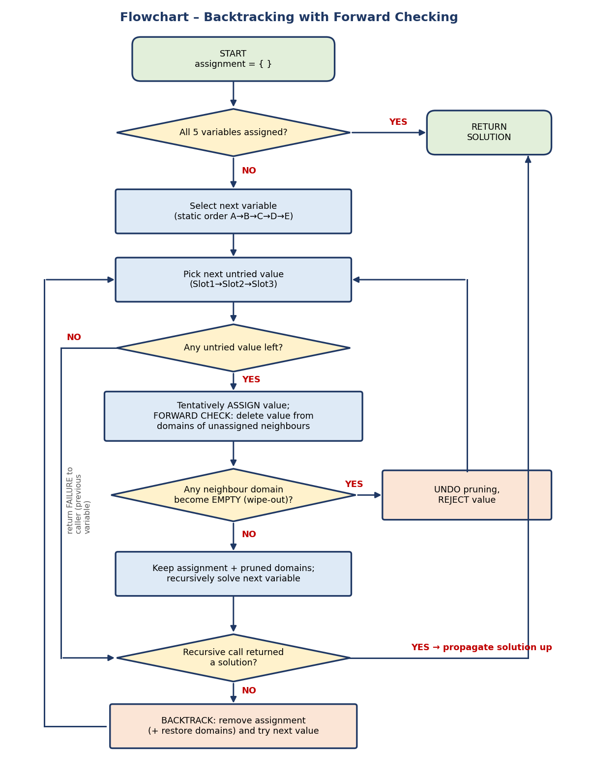
Figure 5: Flowchart of backtracking with forward checking (extra pruning and wipe-out test).

e.4 Initial domains
Variable | A | B | C | D | E
Domain | {1,2,3} | {1,2,3} | {1,2,3} | {1,2,3} | {1,2,3}
In the tables below 1, 2, 3 denote Slot1, Slot2, Slot3. Pruned values are shown in the “Removed” column.

e.5 Step-by-step assignments with domain pruning
Step | Assignment | Neighbours checked (unassigned) | Values removed | Domains after pruning | Wipe-out?
1 | A = Slot1 | B, C (D, E are not adjacent to A) | Slot1 from B  Slot1 from C | A:{1} B:{2,3} C:{2,3}  D:{1,2,3} E:{1,2,3} | No
2 | B = Slot2  (Slot1 already pruned, so first value tried is Slot2) | C, D (A already assigned) | Slot2 from C  Slot2 from D | A:{1} B:{2} C:{3}  D:{1,3} E:{1,2,3} | No
3 | C = Slot3  (only value left in C’s domain) | D, E (A, B already assigned) | Slot3 from D  Slot3 from E | A:{1} B:{2} C:{3}  D:{1} E:{1,2} | No
4 | D = Slot1  (only value left in D’s domain) | E (B, C already assigned) | Slot1 from E | A:{1} B:{2} C:{3}  D:{1} E:{2} | No
5 | E = Slot2  (only value left in E’s domain) | None (all neighbours assigned) | – | All variables assigned | No

e.6 Domain evolution summary

Stage | A | B | C | D | E
Initial | {1,2,3} | {1,2,3} | {1,2,3} | {1,2,3} | {1,2,3}
After A = 1 | {1} | {2,3} | {2,3} | {1,2,3} | {1,2,3}
After B = 2 | {1} | {2} | {3} | {1,3} | {1,2,3}
After C = 3 | {1} | {2} | {3} | {1} | {1,2}
After D = 1 | {1} | {2} | {3} | {1} | {2}
After E = 2 | {1} | {2} | {3} | {1} | {2}
Green = variable just assigned; yellow = domains reduced by forward checking in that step. In total 2 + 2 + 2 + 1 = 7 values were pruned.

e.7 Search tree
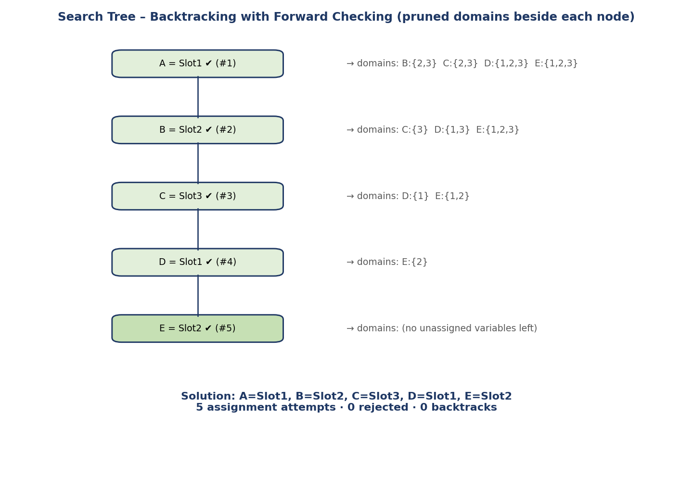
Figure 6: Search tree for forward checking with the pruned domains after each assignment.

e.8 Explanation and justification
- After A = Slot1, B and C lose Slot1 because they are adjacent to A. The failed attempt B=Slot1 of the plain search never happens.
- After B = Slot2, C is left with a single value {Slot3}. Both wasted attempts C=Slot1 and C=Slot2 (Steps 4–5 of Part d) disappear.
- After C = Slot3, D’s domain becomes {Slot1} and E’s becomes {Slot1, Slot2}; no domain is empty, so no dead end is detected.
- After D = Slot1, E is reduced to {Slot2}. The failed attempt E=Slot1 of Part (d) is avoided, and E=Slot2 is assigned directly.
- At every step every unassigned domain stayed non-empty, so there was no wipe-out and 0 backtracks.

e.9 Final valid timetable
Exam slot | Course(s) scheduled | Day
Slot1 | A – Artificial Intelligence, D – Operating Systems | Day 1
Slot2 | B – Database Systems, E – Software Engineering | Day 2
Slot3 | C – Computer Networks | Day 3

Assignment: A = Slot1, B = Slot2, C = Slot3, D = Slot1, E = Slot2 – identical to the plain-backtracking result and verified against all 7 constraints in Part (d.8).
Metric | Value
Assignment attempts | 5
Rejected attempts | 0
Backtracks | 0
Domain values pruned | 7

Part (f) – Comparative Analysis

f.1 Quantitative comparison

Metric | Plain Backtracking | Backtracking + Forward Checking | Difference
Assignment attempts | 9 | 5 | 4 fewer (↓ 44.4%)
Rejected (failed) attempts | 4 | 0 | 4 fewer
Accepted attempts (= number of variables) | 5 | 5 | Same
Backtracks (undoing earlier assignment) | 0 | 0 | Same for this instance
Domain values pruned (extra work) | 0 | 7 | 7 more
Solution found | A=S1, B=S2, C=S3, D=S1, E=S2 | A=S1, B=S2, C=S3, D=S1, E=S2 | Identical

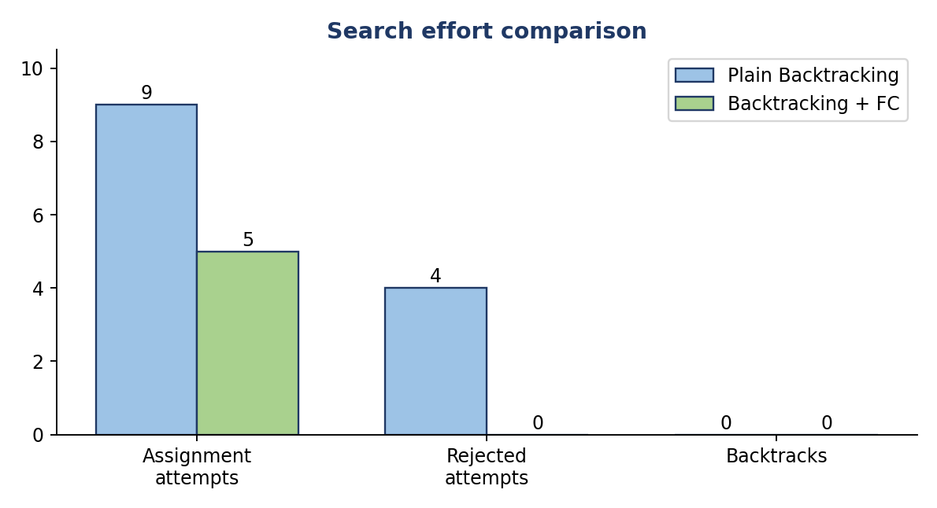
Figure 7: Search effort of the two algorithms on the exam-scheduling CSP.

f.2 Forward checking save work
Plain-search attempt that was wasted | Forward-checking step that removed it
Step 2: B = Slot1 (clashes with A) | Slot1 pruned from B after A = Slot1
Step 4: C = Slot1 (clashes with A) | Slot1 pruned from C after A = Slot1
Step 5: C = Slot2 (clashes with B) | Slot2 pruned from C after B = Slot2
Step 8: E = Slot1 (clashes with D) | Slot1 pruned from E after D = Slot1
Exactly the four rejected attempts in plain backtracking (9 − 5 = 4) are the ones forward checking eliminates, which explains the entire difference in attempts.

f.3 Comparison of efficiency
- Number of assignment attempts: FC needs 5 attempts, one per variable, which is the minimum possible for 5 variables. Plain backtracking needs 9, i.e. 80% more attempts than necessary.
- Number of backtracks: both algorithms needed 0 backtracks here, because with this variable/value order the first legal choice at every level leads to a solution. This is a property of this particular instance and ordering, not an advantage of either algorithm.
- Overall efficiency: FC does less search (fewer nodes in the tree) but performs 7 pruning operations. Since each pruning is a cheap domain deletion, and each wasted attempt in plain backtracking also costs a consistency test, FC is more efficient overall for this problem, but the gain is modest because the problem is tiny.
- Solution quality: both return the same valid timetable; FC does not change correctness, only effort.

f.4 Checking reduces the search effort
- It prevents known-bad choices. A value that conflicts with an assigned neighbour is removed in advance, so the algorithm never spends an attempt on it (e.g. C’s domain shrinks to {Slot3} before C is reached).
- It detects dead ends early. If pruning empties some future variable’s domain, the current assignment is rejected right away. Plain backtracking would only discover the dead end much later, after assigning further variables, and could waste a whole subtree.
- It propagates information forward. Each assignment passes its consequence to all unassigned neighbours immediately, so later variables work with smaller, already-consistent domains.
- It keeps the tree narrow. The branching factor falls from 3 to 2, 1, 1, 1 along the path (domain sizes at selection time: A=3, B=2, C=1, D=1, E=1), whereas plain backtracking always considers all 3 values at each level.

f.5 Limitations and wider perspective
- Forward checking only checks neighbours of the variable just assigned; it does not detect conflicts between two unassigned variables (that needs arc consistency / AC-3).
- On this small CSP the worst case of plain backtracking is bounded by 3^5 = 243 complete assignments, but only 9 attempts were used. The benefit of FC grows quickly with more variables, tighter constraints and orderings that lead to dead ends.
- Combining FC with the MRV (choose the variable with the fewest remaining values, here C first) and degree heuristics would reduce search effort further, although the question fixes a static order.

f.6 Conclusion

The constraint-based examination scheduling problem demonstrates how Artificial Intelligence techniques can be used to solve real-world scheduling problems efficiently and systematically. In this problem, five university courses—Artificial Intelligence (A), Database Systems (B), Computer Networks (C), Operating Systems (D), and Software Engineering (E)—must be scheduled across three examination slots while satisfying all the specified conflict constraints. The problem was successfully modeled as a Constraint Satisfaction Problem (CSP) by defining the courses as variables, the three examination slots as their domains, and the student-enrollment conflicts as constraints.

Appendix – Python Implementation and Output

A.1 Source code (csp_solver.py)
The program below implements both algorithms with the same variable order and value order used in this report, and counts attempts, rejections and backtracks.
"""Exam-scheduling CSP: plain Backtracking vs Backtracking + Forward Checking."""
import copy

VARIABLES = ["A", "B", "C", "D", "E"] # static order A->B->C->D->E
DOMAIN = ["Slot1", "Slot2", "Slot3"] # value order Slot1->Slot2->Slot3
EDGES = [("A","B"),("A","C"),("B","C"),("B","D"),("C","D"),("C","E"),("D","E")]

NEIGHBOURS = {v: set() for v in VARIABLES}
for u, v in EDGES:
NEIGHBOURS[u].add(v); NEIGHBOURS[v].add(u)

def consistent(var, val, assignment):
"""Value is legal if no already-assigned neighbour uses the same slot."""
return all(assignment.get(n) != val for n in NEIGHBOURS[var])

# ---------------------------------------------------------------- plain BT
def backtracking(assignment, stats, log):
if len(assignment) == len(VARIABLES):
return assignment
var = VARIABLES[len(assignment)] # static variable order
for val in DOMAIN: # static value order
stats["attempts"] += 1
if consistent(var, val, assignment):
log.append((stats["attempts"], var, val, "ACCEPTED"))
assignment[var] = val
result = backtracking(assignment, stats, log)
if result: return result
del assignment[var] # undo -> BACKTRACK
stats["backtracks"] += 1
log.append((stats["attempts"], var, val, "BACKTRACK"))
else:
stats["failed"] += 1
log.append((stats["attempts"], var, val, "REJECTED (conflict)"))
return None

# ------------------------------------------------------- BT + forward check
def forward_checking(assignment, domains, stats, log):
if len(assignment) == len(VARIABLES):
return assignment
var = VARIABLES[len(assignment)]
for val in list(domains[var]): # only surviving values
stats["attempts"] += 1
new_domains = copy.deepcopy(domains)
new_domains[var] = [val]
pruned, wipeout = [], False
for n in NEIGHBOURS[var]:
if n not in assignment and val in new_domains[n]:
new_domains[n].remove(val) # forward-check pruning
pruned.append((n, val))
if not new_domains[n]: wipeout = True
if wipeout:
stats["failed"] += 1
log.append((stats["attempts"], var, val, "WIPE-OUT", pruned, new_domains))
continue
assignment[var] = val
log.append((stats["attempts"], var, val, "ACCEPTED", pruned, new_domains))
result = forward_checking(assignment, new_domains, stats, log)
if result: return result
del assignment[var]
stats["backtracks"] += 1
return None

if __name__ == "__main__":
s1 = {"attempts":0,"failed":0,"backtracks":0}; l1 = []
sol1 = backtracking({}, s1, l1)
print("PLAIN BACKTRACKING"); [print(" ", r) for r in l1]
print(" solution:", sol1, s1)

s2 = {"attempts":0,"failed":0,"backtracks":0}; l2 = []
init = {v: list(DOMAIN) for v in VARIABLES}
sol2 = forward_checking({}, init, s2, l2)
print("\nFORWARD CHECKING")
for r in l2: print(" ", r[:5]); print(" domains:", r[5])
print(" solution:", sol2, s2)

A.2 Program output
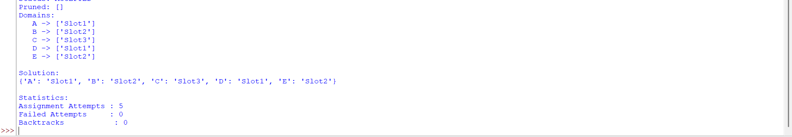
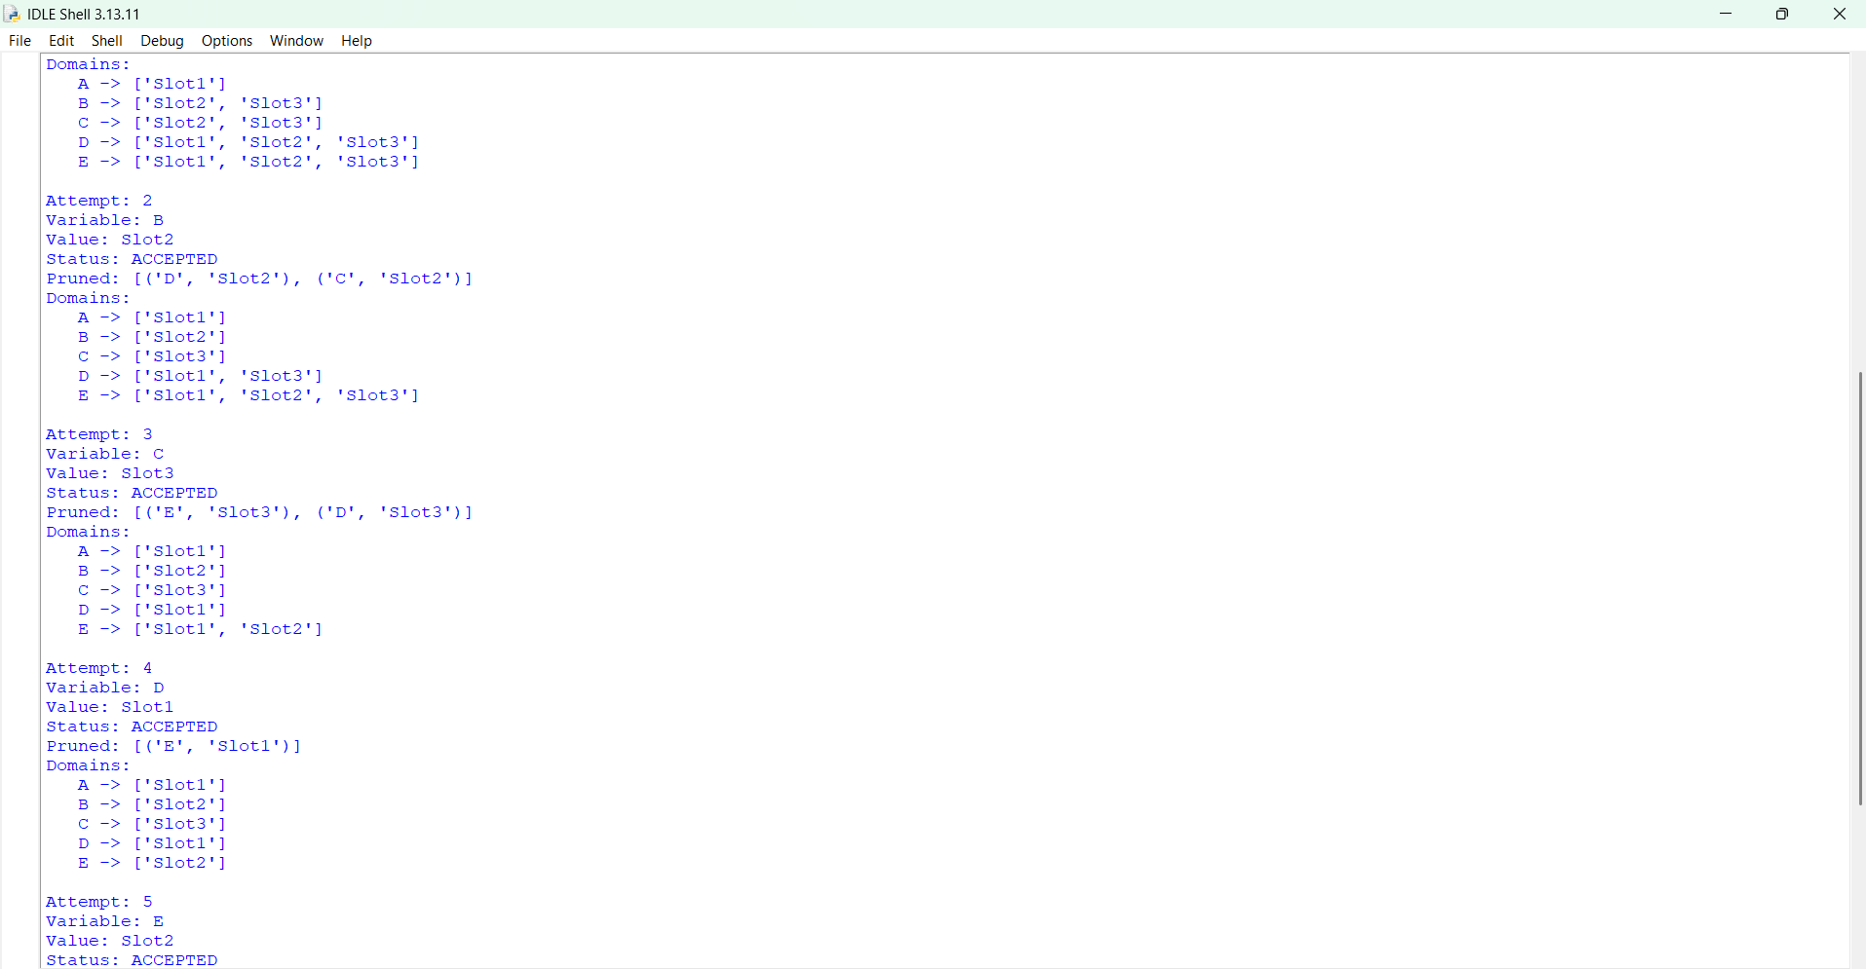
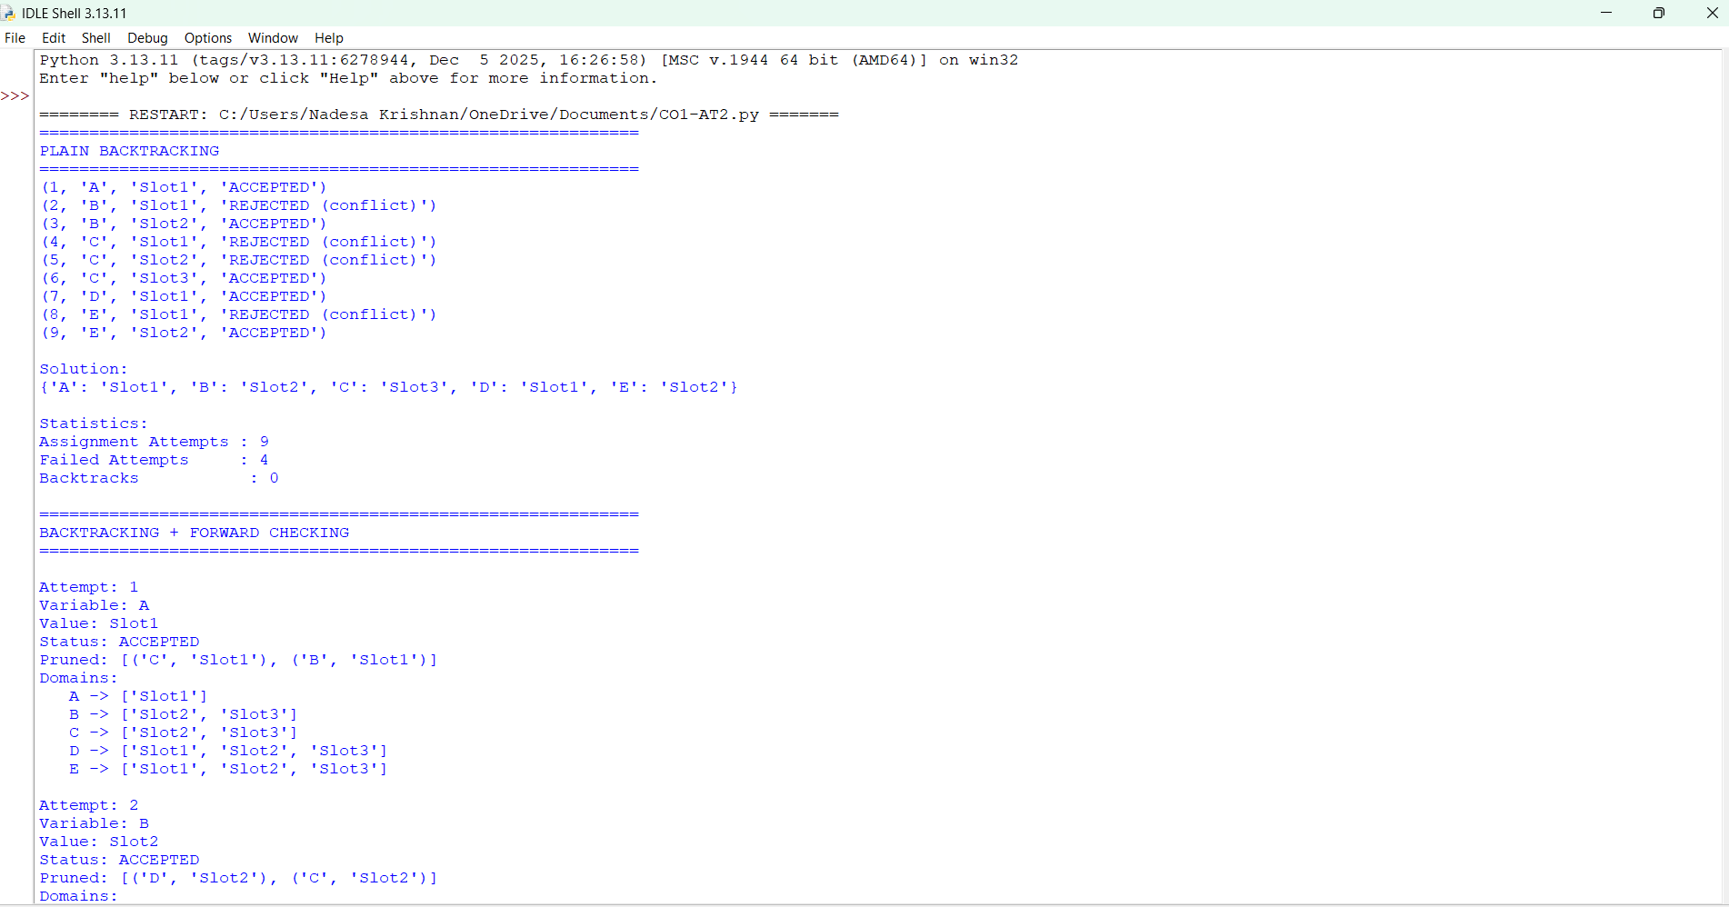
The output matches the hand-worked tables in Parts (d) and (e): 9 attempts / 4 rejected / 0 backtracks for plain backtracking and 5 attempts / 0 rejected / 0 backtracks for forward checking.

